Methods
Participant & Data
The dataset used in this project was from OpenNeuro, and consisted of functional magnetic resonance imaging (fMRI) scans from 79 participants, including 35 individuals diagnosed with Attention Deficit Hyperactivity Disorder (AHDH) and 44 control participants. The fMRI data were collected during working memory tasks that varied in cognitive load (e.g., easy vs. hard conditions) and reward contingencies. These task-based conditions were included to elicit neural activation patterns associated with executive functioning and reward processing, domains commonly implicated in ADHD.
The dataset was partitioned into training and testing subsets. Approximately 518 samples were used for training, while 28 samples were reserved for testing model performance. Each sample consisted of a three-dimensional brain volume representing blood-oxygen-level-dependent (BOLD) activity across voxels.

Data Preprocessing
Neuroimaging data were processed using the Python library NiBabel, which enables the loading and manipulation of NIfTI (.nii) files. Each fMRI scan was converted into a numerical array representing voxel-wise brain activity.
To improve model performance and stability during training, voxel intensity values were normalized to a standard range. Labels were extracted from accompanying participant metadata, where ADHD diagnoses were encoded as binary values (ADHD = 1, control = 0). This preprocessing ensured that the data were in a suitable format for input into the neural network.

Model Structure
A Convolutional Neural Network (CNN) was implemented using TensorFlow and Keras. CNNs were selected due to their demonstrated effectiveness in analyzing spatially structured data such as images and neuroimaging volumes. Because fMRI data consist of voxel-based representations of brain activity, CNNs are well-suited to capture spatial dependencies and distributed activation patterns.
The model architecture consisted of the following layers:
- Convolutional layers, which applied multiple filters across the input data to detect local spatial patterns in brain activity
- Rectified Linear Unit (ReLU) activation functions, which introduced non-linearity and enabled the model to learn complex relationships
- Pooling layers, which reduced the spatial dimensionality of feature maps and helped retain the most salient features while minimizing noise
- Normalization layers, which stabilized learning by maintaining consistent activation distributions
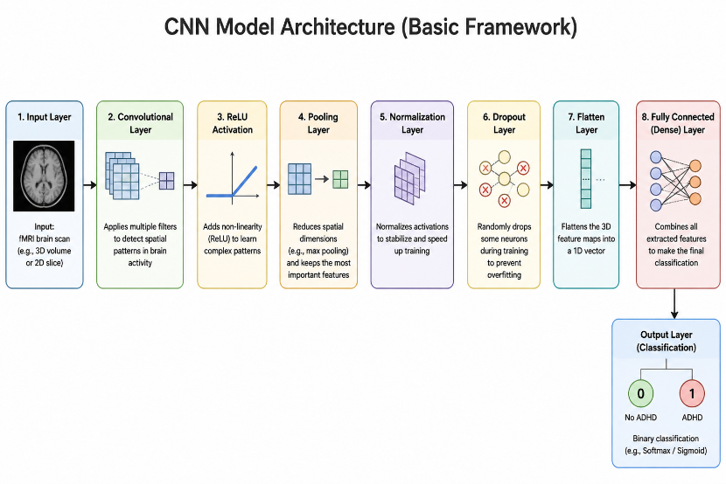
- Dropout layers, which randomly deactivated a subset of neurons during training to reduce overfitting
- A flattening layer, which transformed multidimensional feature maps into a one-dimensional vector
- A fully connected (dense) layer, which integrated extracted features and produced a binary classification output

This layered structure allowed the model to progressively extract low-level to high-level features from the input data, ultimately enabling classification of ADHD versus control participants.

Training Procedure and Evaluation
The model was trained using supervised learning, where input fMRI scans were paired with corresponding diagnostic labels. During training, the model iteratively adjusted its internal parameters to minimize prediction error.
Model performance was evaluated on the held-out test set using multiple metrics, including overall accuracy, a confusion matrix, and a classification report. Learning curves were also generated to assess training and validation performance over time, allowing for the detection of overfitting or underfitting.

Results
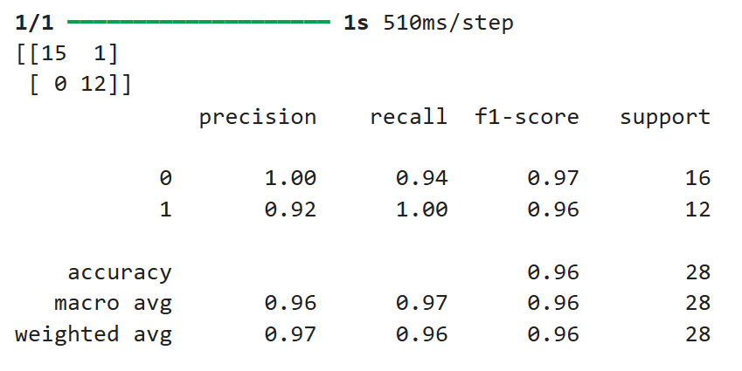
The Convolutional Neural Network (CNN) demonstrated strong performance in classifying individuals with Attention-Deficit/Hyperactivity Disorder (ADHD) based on fMRI data, achieving an overall accuracy of 96% on the test dataset (n = 28). This high level of accuracy indicates that the model was able to correctly distinguish between ADHD and control participants in most cases for this sample. Examination of the confusion matrix revealed 15 true positives (correctly identified ADHD cases) and 12 true negatives (correctly identified control participants), along with 1 false positive and 0 false negatives. These results indicate that the model successfully identified all ADHD cases in the test set while producing only a single misclassification among control participants. Although some misclassifications were present, this is expected given the complexity and heterogeneity of ADHD as a clinical condition.

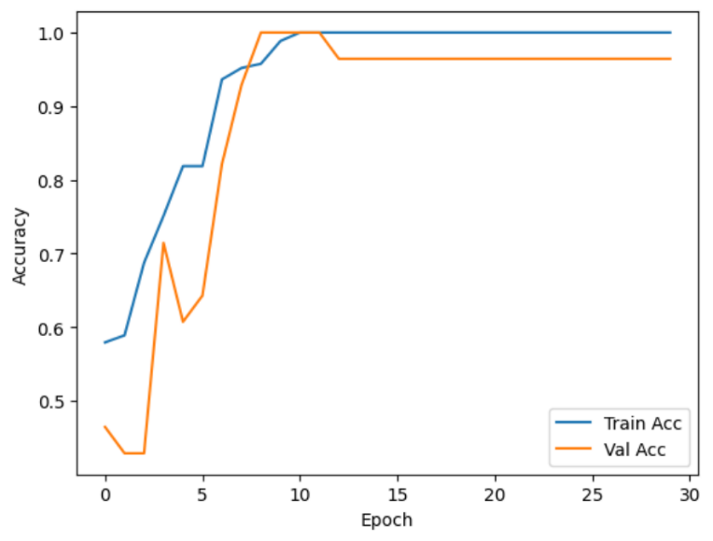
Analysis of training and validation performance across epochs showed that both accuracy curves increased steadily before reaching a plateau, with no substantial divergence between them. This pattern suggests that the model generalized well to unseen data and was not significantly affected by overfitting. The convergence of training and validation accuracy indicates that the model effectively learned meaningful patterns in the data rather than memorizing the training set.

The model’s predictions were based on spatial patterns of brain activity derived from blood-oxygen-level-dependent (BOLD) signals measured through fMRI. Although the CNN does not explicitly isolate individual brain regions in a traditional statistical framework, the learned representations are consistent with prior research on ADHD. In particular, the classification process likely relied on distributed activation patterns in regions associated with executive functioning and reward processing, including the striatum, basal ganglia, caudate nucleus, and putamen.
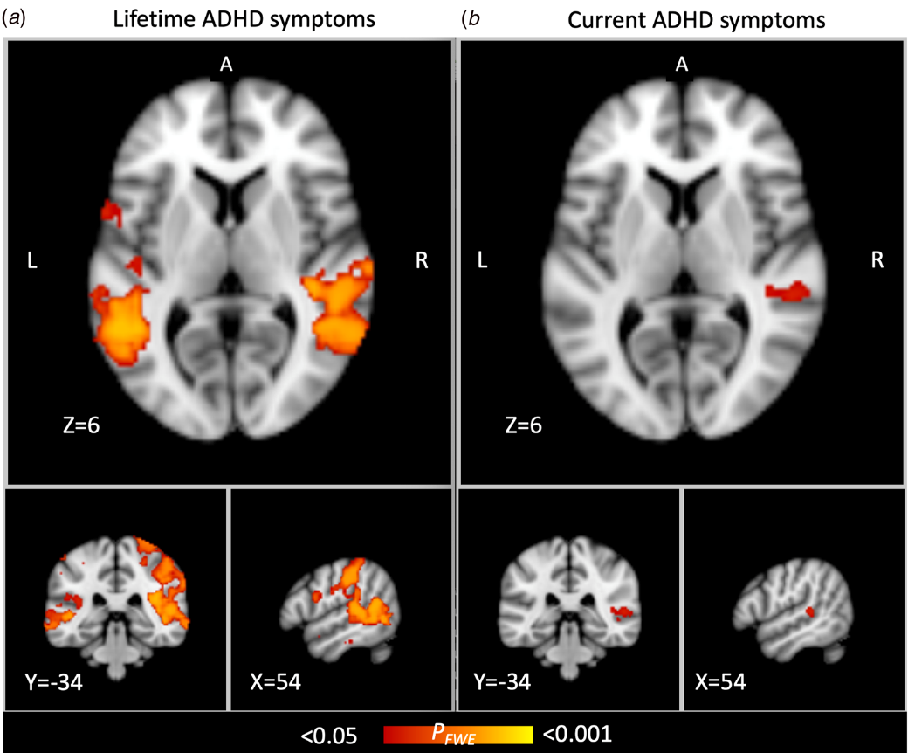
Beyond these discrete anatomical localizations, the model’s performance may be contextualized through the lens of macroscale cortical gradients, which describe the continuous hierarchical organization of the brain. In neurotypical populations, the principal functional gradient spans from unimodal sensory-motor regions to transmodal association areas, such as the Default Mode Network (DMN; Knodt et al., 2023). Recent evidence suggests that ADHD is characterized by an atypical contraction or "flattening" of this gradient, where the functional segregation between sensory-motor systems and high-level cognitive networks is diminished. This systemic compression reflects a failure to suppress task-irrelevant DMN activity during goal-directed tasks, potentially explaining the intrusion of internal thoughts into external cognitive processes
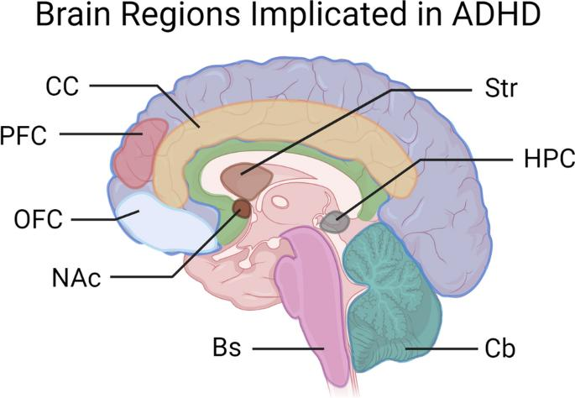
These regions have been widely implicated in attentional control, impulsivity, and reward sensitivity, all of which are core features of ADHD (Paloyelis et al., 2007). Overall, the findings suggest that the model successfully captured meaningful neural patterns that differentiate ADHD from non-ADHD individuals, supporting the potential utility of deep learning approaches in neuroimaging-based classification tasks.

Bibliography
Knodt, A. R., Elliott, M. L., Whitman, E. T., Winn, A., Addae, A., Ireland, D., Poulton, R., Ramrakha, S., Caspi, A., Moffitt, T. E., & Hariri, A. R. (2023). Test-retest reliability and predictive utility of a macroscale principal functional connectivity gradient. Human brain mapping, 44(18), 6399–6417. https://doi.org/10.1002/hbm.26517
Paloyelis, Y., Mehta, M. A., Kuntsi, J., & Asherson, P. (2007). Functional MRI in ADHD: a systematic literature review. Expert review of neurotherapeutics, 7(10), 1337–1356. https://doi.org/10.1586/14737175.7.10.1337

